|  |
| --- |
| 新东方在线英语学习 |
| 新概念 1 册 |
| Lesson87-88 |



扫一扫。更多有趣的英语资讯。

# Lesson 87 单词讲解

attendant: n.接待员 e tai den te

bring: v.带来，送来

take， 带 走 bring sth.\sb. to…

Please bring your new book to me. take sth.\sb. to…

I am going to take this pen to her.

1. May I my boyfriend here next time?

A. bring B. take

C .more D. carry

1. The young man flowers for the girl every day.

A. fetches B. brings

C. takes D. carries

fetch, 取 carry，随身携带

garage: n.车库，汽车修理厂ge rua zhi

1. 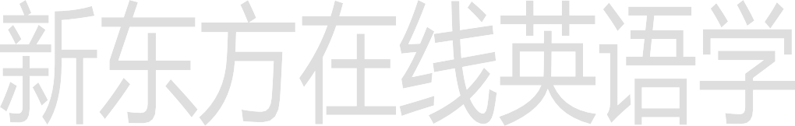crash: n.碰撞a car crash an air crash
2. lamp-post: 灯杆
3. repair: v.修理repair my car
4. try: v.努力，设法 try to … 努力去做…

They are trying to finish it.

try one’s best to…尽某人最大的努力… one’s- my\ his\ her\ our\ their

He tried his best to study English.

# Lesson 87 课文讲解

1. Is my car ready yet? yet:

到现在为止 否定和疑问句

一般现在 & 现在完成Have your mechanics finished yet? 翻译为：了

yet:

还，仍

否定和疑问句

一般现在 & 现在完成

He is not ready to quit yet.

I haven't really got into my new job yet. Not yet. 还没呢!

1. What’s the number of your car? What’s your car number?
2. I remember now.

我想起来了。

1. still working on it

仍在干呢

* + Have you finished Book 1?
  + Not yet. I’m still working on it.

我还在学呢~

* + Have you cooked the meal?
  + Not yet. I’m still working on it.

我还在做呢~

1. 看一看: have a look 试一试: have a try 尝一尝: have a taste tei si te

我想看一看你的新车。

I want to have a look at your new car.

我可以尝一尝你的奶酪吗？

Can I have a taste of your cheese?

1. I drove it into a lamp-post. into, 进入
2. To tell you the truth,…

说句老实话吧，…

# Lesson 87 语法讲解

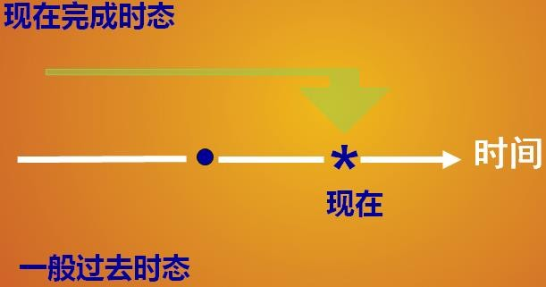

现在完成：

过去发生，立足现在一般过去：

过去发生，无关现在

He has got married. 他已婚.

He got married in 2010. 他 2010 年结的婚。

I have graduated. 我毕业了。

I graduated in 2006 我 2006 年毕业的。

I have finished Book1. 我学完一册了。

I finished Book1 last week. 我上周学完一册的。

I have been to New York. 我去过纽约。

I went to New York in 2010. 我在 2010 年去纽约的。

1.- you the text yet ?

- Yes, we it two hours ago.

1. Did…copy…did
2. Have…copied…have
3. Did…copied…did
4. Have… copied…did

2.My mother me a new coat yesterday.



I it on. It fits me well.

1. had made…have tried
2. made…have tried
3. has made…tried
4. made…tried

# Lesson 88 单词句型讲解

Have you … yet?



1. read- read- read 读cut- cut- cut 切,割let- let- let 让

put- put- put 放

cost- cost- cost 花费,值set-set- set 落下、安置hurt- hurt- hurt 使…伤痛

1. fly- flew- flown 飞
2. draw- drew- drawn 画zhu ang zhu zhuang n
3. grow- grew- grown 生长ge ru ge rou n

know- knew- known 知道 no en

1. begin- began- begun 开始be gang en
2. drink- drank- drunk 喝 zhu an ke zhu ang ke
3. sing- sang- sung 唱san en sang en

swim- swam- swum 游泳si wa mu

ring- rang- rung 打电话rung en

1. feel- felt- felt 感觉keep- kept- kept 保持leave- left- left 离开sleep- slept- slept 睡觉

sweep- swept- swept 打扫

1. catch- caught- caught 捉,抓

teach- taught- taught 教

1. meet- met- met 遇见get- got- got 得到hold- held- held 举行sit- sat- sat 坐

win- won- won 赢

1. build- built- built 建造send- sent- sent 送,寄spend- spent- spent 花费make- made- made 制造hear- heard- heard 听见

**Lesson 87&88 知识拓展**填入 has / have been 或 has / have gone.

1. Sam： Sally and Tim are on holiday, aren't they? Where they ?

Sue： To Florida, again.

Sam： How many times they there? Sue： This is their third visit.

1. Harry: I saw you in Annabel's Restaurant last night. Diana: No, it wasn't me. I never there.
2. Alan: Where's Tony?

Mary: He's got a headache so he to bed.

1. Steve: Can I speak to Jill, please?

Lynn: She's out, I'm afraid. She to the cinema this evening.